

DC POWER + WIRELESS LIGHTING CONTROLS
COMMERCIAL APPLICATIONS GUIDE
Conceptual Design Edition | August 2026
A room-by-room design guide for direct-current lighting distribution, wireless occupancy/daylight sensing, self-powered wall controls, and integration into the Symple Buildings digital building platform.
DESIGN INTENT
Reduce branch-conversion losses, simplify room controls, expose circuit-level power data, and standardize repeatable commercial space applications.
CONCEPTUAL - NOT FOR CONSTRUCTION

CONTENTS + GUIDE INTENT | INTRODUCTION

How to use this guide
This guide follows the room-by-room application pattern used by leading commercial lighting-control guides: each application shows a conceptual layout, control sequence, recommended control strategies, and a basis-of-design component set. It is intended for early design, sales engineering, estimating, and coordination - not as a substitute for project electrical drawings, product listings, or local code requirements.
# | Section | Purpose
1 | Platform overview | DC distribution + control architecture
2 | Design rules | Circuiting, zoning, controls, commissioning
3 | Private office | Manual dimming + occupancy + daylight
4 | Open office | Multi-zone + daylight + occupancy
5 | Conference room | Scenes + presentation mode
6 | Classroom / training | Two-zone teaching + daylight
7 | Break room | Vacancy-oriented control
8 | Restroom | Occupancy automatic-off
9 | Egress corridor | Reduced level / occupied response
10 | Egress stairwell | Safe reduced-level strategy
11 | Atrium / lobby | Large-area zoning + schedules
12 | Schedules + commissioning | BOM and startup checklist

Control philosophy
- DC power is centralized and monitored; room-level loads are distributed as low-voltage DC branches appropriate to the listed equipment and project wiring method.
- Occupancy, ambient light, wall control, scenes, and scheduling are software-defined wherever supported, minimizing dedicated control wiring.
- Each space is designed as a repeatable application package with clear zones, a sequence of operation, and commissioning settings.
- Life-safety and emergency lighting functions remain subject to the project emergency-power strategy, product listings, and authority having jurisdiction.

PLATFORM OVERVIEW | SYSTEM ARCHITECTURE

A DC-first lighting and controls platform
The Symple Buildings concept combines centralized intelligent DC power distribution with wireless room controls and a supervisory digital-building layer. The power and control planes are intentionally separated: lighting power remains on monitored DC branches while room behavior can be configured through wireless controls and software.
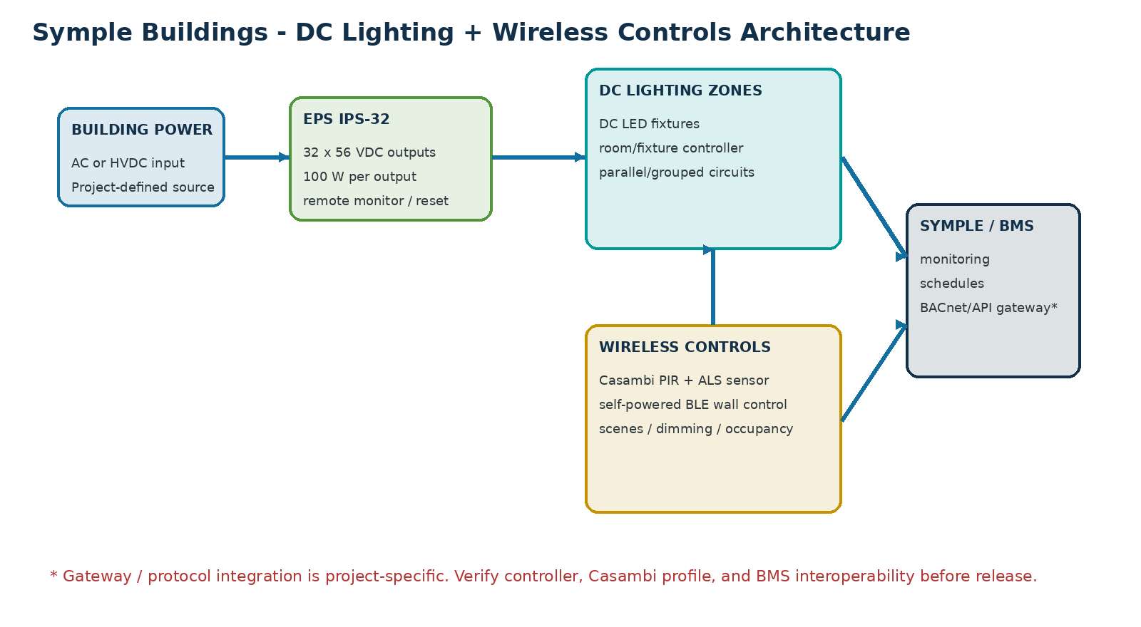
Layer | Basis-of-design | Application value
DC distribution | EPS IPS-32: 32 outputs, 56 VDC, 100 W/output | Centralized conversion, per-port status, remote reset/control, grouped outputs
Presence/daylight | Casambi NASSR PDS-BAT-CAS PIR + ambient light sensor | Wireless occupancy/vacancy logic and light-level sensing
Wall control | mwConnect PSC-EO-WS BLE self-powered controller | Batteryless manual on/off, dimming, scenes / tunable-white control where supported
Room topology | SmartDC-style low-voltage branch / network architecture | Repeatable room nodes, sensors, relays/controllers and DC luminaire circuits
Supervisory layer | Symple Buildings integration | Schedules, diagnostics, energy data, APIs/BMS gateways - project specific

DESIGN RULES | BASIS OF DESIGN

Core electrical + controls rules

1. Zone the room before choosing devices
Define general, perimeter/daylight, task/whiteboard, presentation, and egress zones first. Tie DC branch grouping and control logic to these functional zones.

2. Keep power distribution observable
Assign IPS-32 output labels by floor/room/zone. Use linked output groups only where the loads are intended to operate together.

3. Use wireless controls to reduce control wiring
Place occupancy/daylight sensors for coverage and self-powered wall controls at natural entry points. Verify the exact controller/profile compatibility before procurement.

4. Treat daylight as a distinct control layer
Perimeter fixtures should be separately controllable so ambient-light sensing can trim only the zone receiving useful daylight.

5. Preserve local control
Even when schedules/BMS are present, occupants should retain intuitive local control where appropriate. Central schedules should set defaults, not create confusing overrides.

6. Commission the sequence, not just the devices
Document manual-on/auto-on choice, timeout, fade, high-end trim, sensor sensitivity, daylight target, scene levels, and post-power-failure startup behavior.

7. Separate concept from compliance
Conductor size, circuit classification, emergency lighting, plenum rules, overcurrent protection, voltage drop, and product listing requirements must be engineered for the specific project.
Compatibility checkpoint: The uploaded Casambi sensor is explicitly a Casambi 2.4 GHz BLE-based proprietary mesh device. The mwConnect wall control is a Bluetooth self-powered controller that must pair with a compatible device/node. This guide treats them as basis-of-design controls, but the final room controller must be selected and validated so both intended control inputs are supported.

PRIVATE OFFICE | APPLICATION

Application intent: Best default package for repeatable offices: one sensor, one wireless wall station, and a small DC lighting branch.
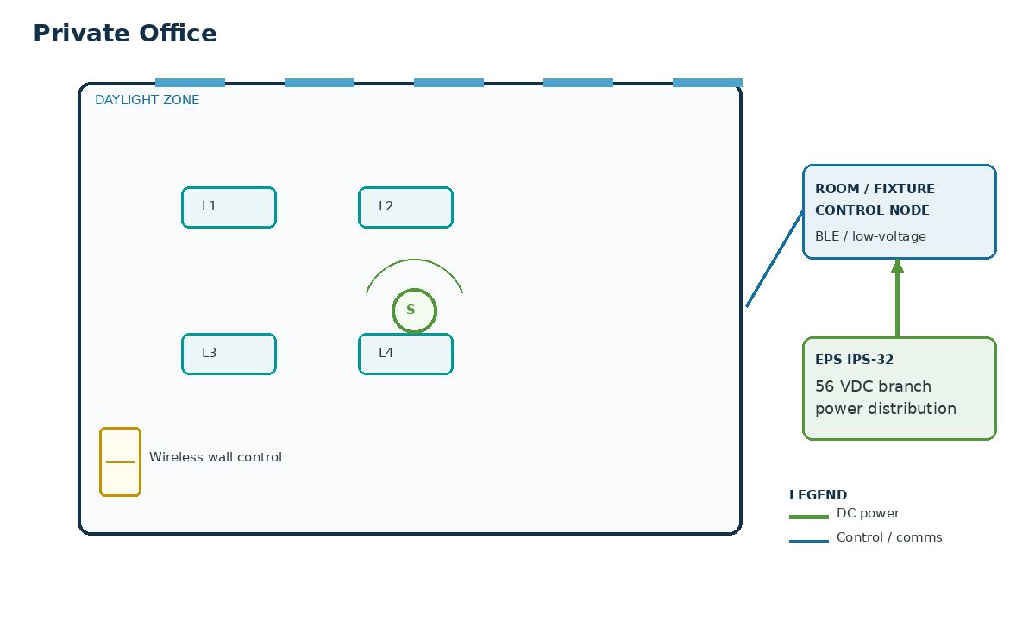
CONTROL STRATEGIES | SEQUENCE OF OPERATION
- Manual-on / auto-off occupancy  - Personal dimming  - Daylight trim at perimeter  - High-end trim | - Entry: lights remain off until the occupant presses the wall control (preferred vacancy mode).  - Occupied: wall control raises/lowers the general zone; perimeter zone is trimmed by available daylight.  - Vacant: occupancy sensor starts the programmed delay; all non-required lighting turns off after timeout.  - After power restoration: IPS-32 port startup behavior returns the room to the approved default state.

Basis-of-design equipment
Qty | Element | Design basis
1 | IPS-32 output | 56 VDC branch assigned to room lighting
1 | Room / fixture controller | DC dimming output compatible with selected luminaires
1 | PIR + ambient sensor | Casambi NASSR PDS-BAT-CAS
1 | Self-powered wall control | mwConnect PSC-EO-WS-100-BLE or compatible profile
4 typ. | DC LED luminaires | One or two control zones

OPEN OFFICE | APPLICATION

Application intent: Use distributed sensing and explicit perimeter zoning rather than a single floor-wide occupancy signal.
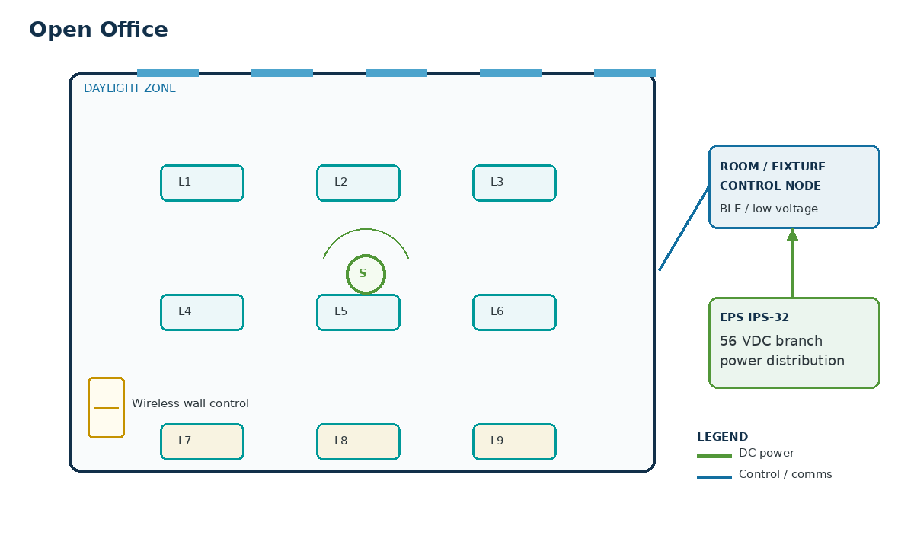
CONTROL STRATEGIES | SEQUENCE OF OPERATION
- Occupancy by area  - Perimeter daylight harvesting  - Multi-zone dimming  - Scheduling / after-hours sweep  - Demand reduction ready | - Business hours: schedule enables the floor while occupancy sensors control local areas.  - Occupied areas: general zones rise to the commissioned level; perimeter rows trim independently with daylight.  - Unoccupied pockets: local zones reduce/off after timeout without shutting down the entire office.  - After hours: schedule drives an off state; local controls can provide timed override where approved.

Basis-of-design equipment
Qty | Element | Design basis
1+ | IPS-32 outputs | Multiple 56 VDC branches by lighting zone
3 typ. | Room/zone controllers | General + perimeter + support zones
2-4 | PIR + ambient sensors | Coverage coordinated with workstation layout
2+ | Self-powered wall controls | Entry + collaboration/support areas
12+ | DC LED luminaires | Grouped by daylight and occupancy zones

CONFERENCE ROOM | APPLICATION

Application intent: Conference rooms benefit from scene logic; use a dual-channel/scene input and separate front-of-room lighting.
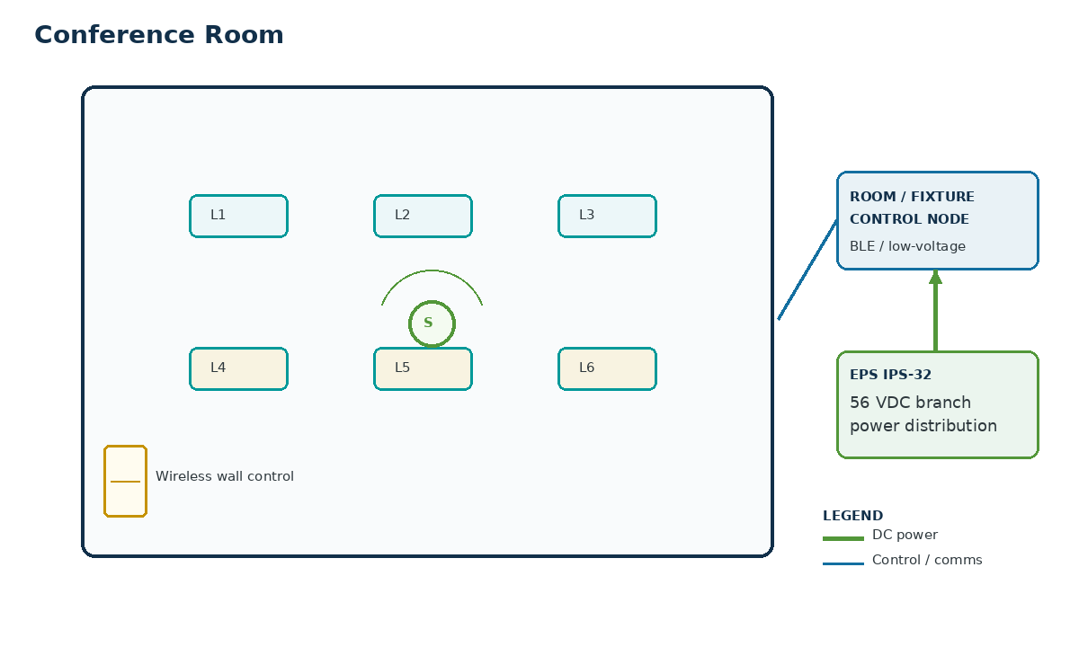
CONTROL STRATEGIES | SEQUENCE OF OPERATION
- Scene control  - Occupancy auto-off  - Presentation mode  - Personal dimming  - Optional tunable white | - Entry: wall station selects General, Presentation, Video, or Off scene.  - Presentation: front/screen zone reduces while table/perimeter lighting remains at the commissioned level.  - Occupied: manual scene changes remain available; occupancy holds the room active.  - Vacant: all normal lighting returns to off after the programmed timeout.

Basis-of-design equipment
Qty | Element | Design basis
1 | IPS-32 output/group | Room lighting DC branch
1-2 | Dual-channel / scene controllers | Scene-capable dimming outputs
1 | PIR + ambient sensor | Ceiling mounted
1 | Dual-rocker self-powered control | PSC-EO-WS-400-BLE for scenes / two-channel use where supported
6 typ. | DC LED luminaires | At least two independently controlled zones

CLASSROOM / TRAINING | APPLICATION

Application intent: Keep the front teaching zone independent from the daylight perimeter so instruction remains visually consistent.
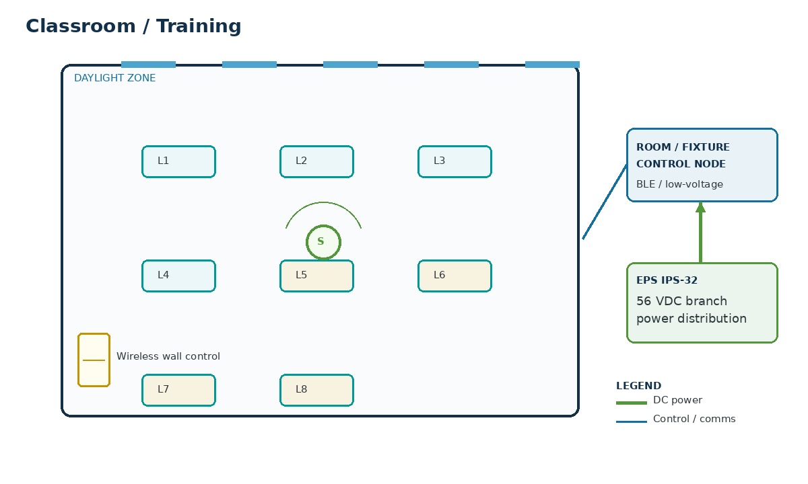
CONTROL STRATEGIES | SEQUENCE OF OPERATION
- Two-zone teaching control  - Occupancy auto-off  - Daylight trim  - High-end trim  - Scene presets | - Entry: instructor enables the room from the wall station.  - Teaching: general zone and front/whiteboard zone are independently dimmable.  - Daylight: window-side fixtures trim to maintain the commissioned target without affecting front-of-room visibility.  - Vacant: lighting turns off after timeout; scheduled shutdown provides a secondary sweep.

Basis-of-design equipment
Qty | Element | Design basis
1-2 | IPS-32 outputs | General + front/whiteboard branches
2 | Control channels | Independent teaching zones
1-2 | PIR + ambient sensors | Coverage based on room size
1 | Scene / dual-channel wall control | Two-zone or scene input
8 typ. | DC LED luminaires | General + front + optional perimeter subgroup

BREAK ROOM | APPLICATION

Application intent: Simple vacancy control delivers most of the benefit with minimal hardware.
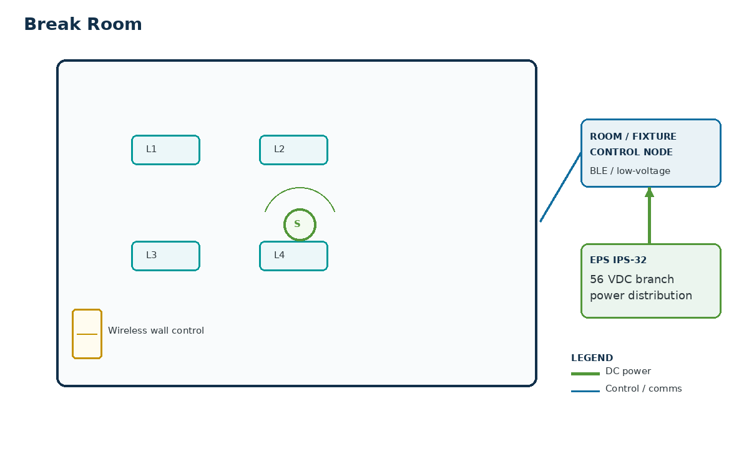
CONTROL STRATEGIES | SEQUENCE OF OPERATION
- Manual-on / auto-off  - Occupancy sensing  - Simple dimming  - Scheduling | - Entry: occupant presses wall control to turn on lighting, or auto-on may be used if preferred by the owner.  - Occupied: lighting remains at the commissioned setpoint with local dimming available.  - Vacant: lights turn off after a short timeout.  - After hours: central schedule keeps the space off except for approved local override.

Basis-of-design equipment
Qty | Element | Design basis
1 | IPS-32 output | Single DC branch
1 | Room controller | Single-zone dimming
1 | PIR sensor | Ceiling coverage
1 | Self-powered wall control | Single rocker
4 typ. | DC LED luminaires | Single zone

MULTI-STALL RESTROOM | APPLICATION

Application intent: Sensor placement is the critical design variable because partitions can block PIR coverage.
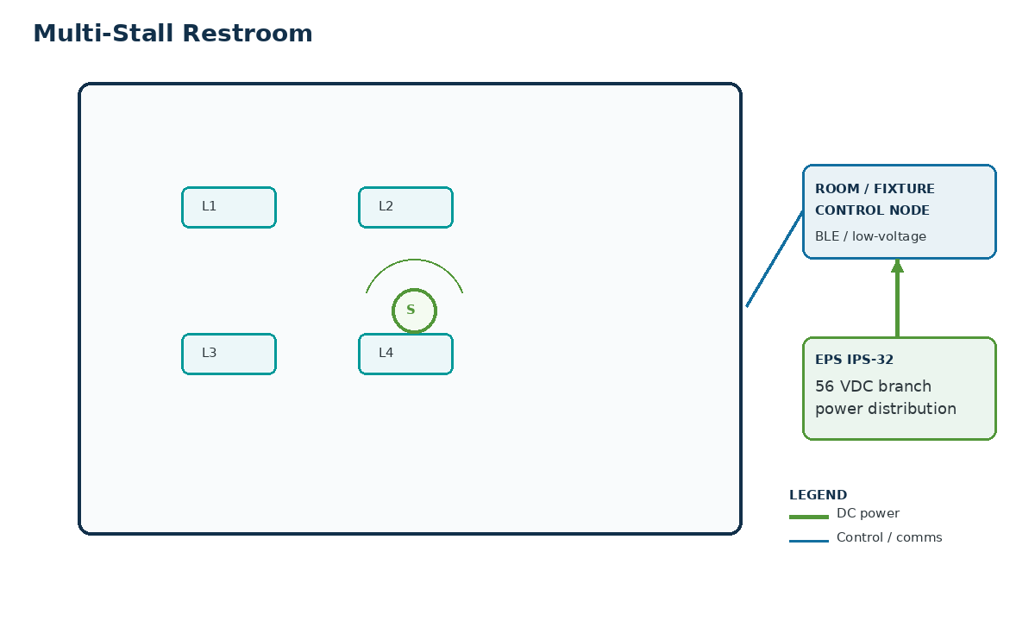
CONTROL STRATEGIES | SEQUENCE OF OPERATION
- Occupancy auto-on / auto-off  - Full-room coverage  - Optional reduced standby level | - Entry: occupancy triggers the normal lighting level.  - Occupied: lights remain on while presence continues; use enough sensors to cover stalls and entry/handwashing zones.  - Vacant: lighting turns off or returns to a permitted reduced level after timeout.  - No routine wall control is required unless the project standard calls for one.

Basis-of-design equipment
Qty | Element | Design basis
1 | IPS-32 output | Restroom lighting branch
1 | Room controller | Switching or dimming output
1-2 | PIR sensors | Coverage verified around partitions
4 typ. | DC LED luminaires | Single or two-zone layout

EGRESS CORRIDOR | APPLICATION

Application intent: Design corridor zoning around travel direction and sensor handoff so users do not enter a dark section.
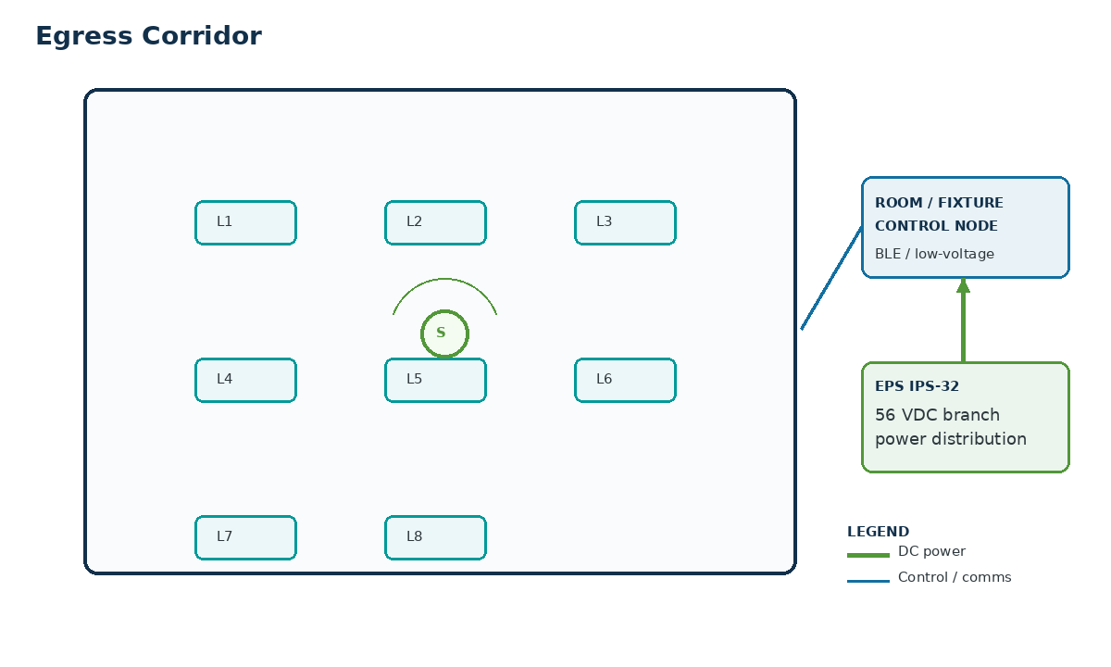
CONTROL STRATEGIES | SEQUENCE OF OPERATION
- Occupancy response  - Reduced unoccupied level  - Scheduling  - Emergency-state coordination | - Normal occupied period: corridor remains at the programmed normal or code-permitted reduced level.  - Presence: sensor raises the affected corridor section to the occupied target.  - No presence: lighting returns to the approved reduced/off state after timeout.  - Emergency: emergency/egress behavior is controlled by the project life-safety design, not by normal wireless occupancy logic.

Basis-of-design equipment
Qty | Element | Design basis
1+ | IPS-32 outputs | Corridor sections by floor/wing
1+ | Zone controllers | Dimming by corridor section
Multiple | PIR sensors | Overlapping coverage along path of travel
8 typ. | DC LED luminaires | Sectional zoning

EGRESS STAIRWELL | APPLICATION

Application intent: Do not treat the stairwell like a conventional office zone; emergency operation and minimum illumination govern the design.
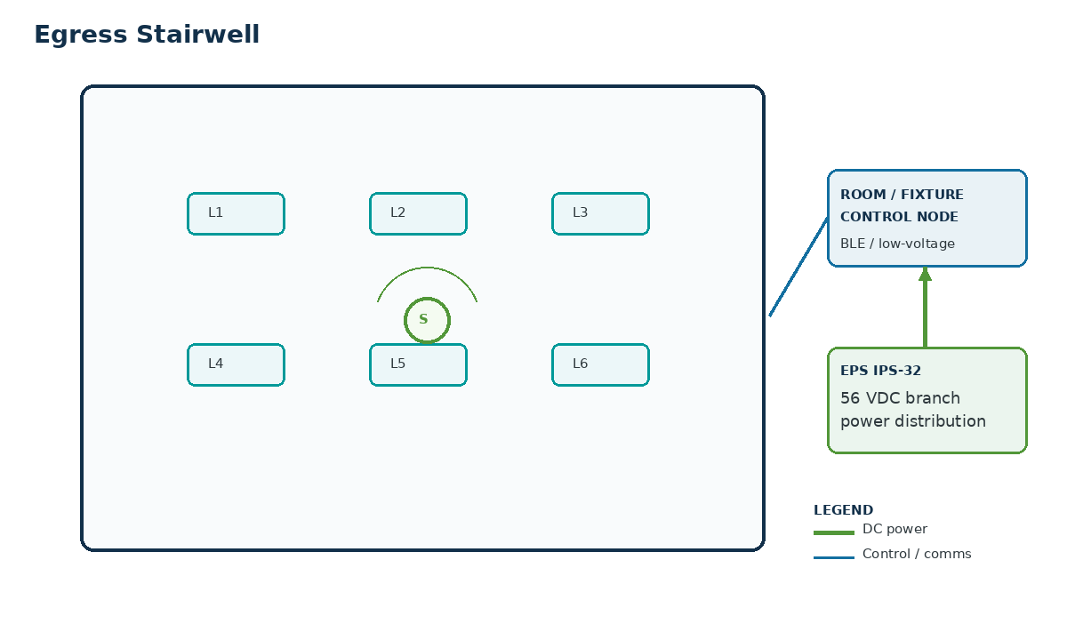
CONTROL STRATEGIES | SEQUENCE OF OPERATION
- Reduced standby level  - Occupancy raise  - Emergency-state coordination  - Continuous monitoring | - Normal standby: fixtures remain at the approved minimum or full level required by the project.  - Presence: stairwell sensor raises the local or full stairwell zone to the occupied target.  - No presence: lighting returns to standby after the specified delay.  - Emergency / fire alarm: life-safety controls override normal energy-saving behavior as required.

Basis-of-design equipment
Qty | Element | Design basis
1+ | IPS-32 outputs | Stairwell floors/sections as engineered
1+ | Dimming controllers | Standby-to-full control
Multiple | PIR sensors | Landings and flights as needed
6 typ. | DC LED luminaires | Listed/approved for application

ATRIUM / LOBBY | APPLICATION

Application intent: Large public spaces are schedule- and scene-driven; occupancy is typically supplemental rather than the only control input.
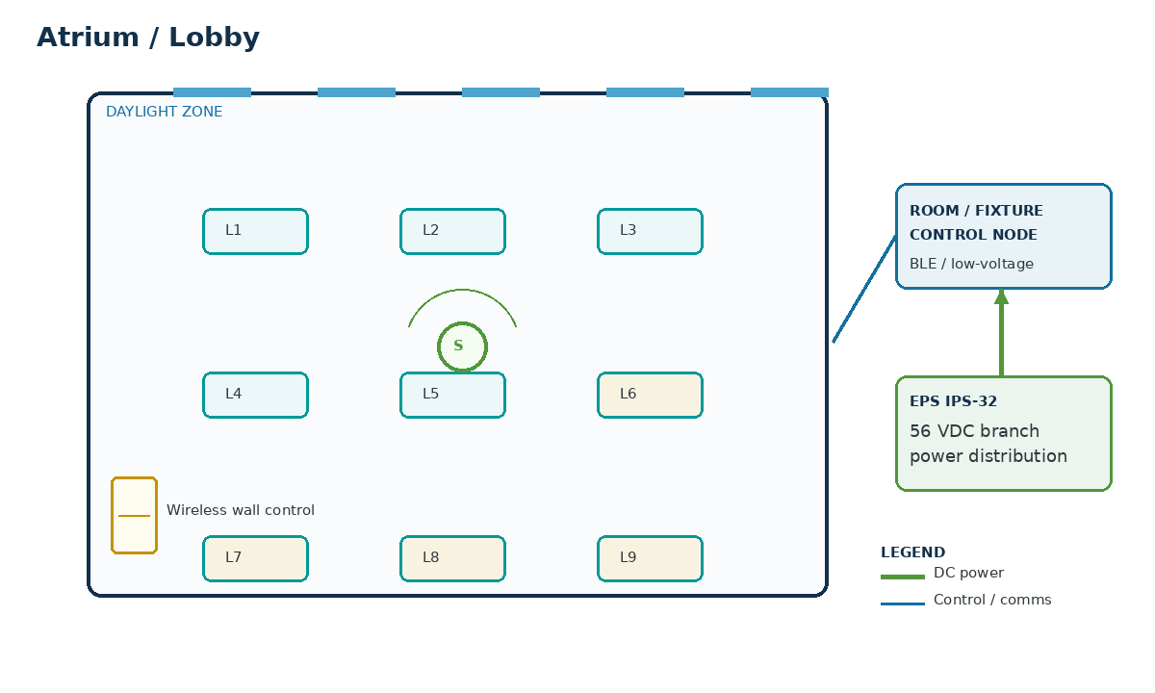
CONTROL STRATEGIES | SEQUENCE OF OPERATION
- Multi-zone scene control  - Daylight harvesting  - Scheduling  - Occupancy assist  - Demand reduction ready | - Open hours: schedule establishes the active scene and enables daylight trim near glazing.  - Occupied: lobby/atrium zones maintain their scene; local staff control can adjust approved zones.  - Bright daylight: perimeter/high-bay zones trim independently to preserve visual balance.  - Closed hours: schedule transitions to security/cleaning scene, then to the approved night state.

Basis-of-design equipment
Qty | Element | Design basis
2+ | IPS-32 outputs/groups | Separate high-bay, perimeter, feature, and support zones
3+ | Control channels | Scene-capable zone control
1+ | PIR + ambient sensors | Used where sensor geometry is appropriate
1+ | Self-powered wall controls | Staff scenes / override
10+ | DC LED luminaires | Multiple architectural zones

COMPONENT REFERENCE | BASIS OF DESIGN

Key components in this guide

EPS IPS-32 intelligent power distribution unit
32 outputs; 56 VDC; 100 W per output; software-controllable on/off/reset; output grouping; network/serial interfaces; remote monitoring. Use as the centralized branch-power platform.

Casambi NASSR PDS-BAT-CAS sensor
Battery-powered PIR + ambient light sensor; Casambi 2.4 GHz BLE-based proprietary mesh; presence/absence scenarios; adjustable sensitivity and latency. Coordinate mounting height and coverage.

mwConnect PSC-EO-WS BLE wall controller
Self-powered, batteryless Bluetooth wall control using an integrated micro-generator; supports manual on/off, wireless dimming, and scene/tunable-white functions depending on the paired controller.

SmartDC-style room architecture
The uploaded SmartDC diagram illustrates a repeatable topology with low-voltage DC feeds plus control/network links to room controllers, PIR sensors, switches, relays, and receptacle interfaces. Use it as a topology reference, not a blanket wiring specification.

IPS-32 configuration practices
- Label each port by building/floor/room/zone.
- Use port current and fault status for service diagnostics.
- Use linked output groups only when simultaneous behavior is intended.
- Set startup state deliberately for post-outage recovery.
- Where multiple outputs are paralleled for a load, follow manufacturer instructions and project engineering.

COMMISSIONING + HANDOFF | STARTUP

Room commissioning checklist
✓ | Item | Acceptance check
☐ | Power | Confirm correct IPS-32 port assignment, output voltage, polarity, branch protection, conductor sizing, and measured load current.
☐ | Fixture control | Verify full on/off range, smooth dimming, minimum level, high-end trim, and zone mapping.
☐ | Wall control | Pair/program the wall station; verify tap, press/hold, scene and override behavior.
☐ | Occupancy | Verify sensor coverage, sensitivity, false-trigger resistance, timeout, and manual-on/auto-on policy.
☐ | Daylight | Set target light level and confirm only intended perimeter/daylight zones respond.
☐ | Schedules | Verify occupied, after-hours, holiday, cleaning and override behavior at the supervisory layer.
☐ | Power recovery | Test IPS-32 startup state and controller/fixture recovery after loss and restoration of source power.
☐ | BMS / API | Verify only the points and commands intended for integration; document ownership of overrides and priority.
☐ | Documentation | Capture final device IDs, port labels, room names, scene levels, timeouts, setpoints, firmware/app versions and as-built changes.

Recommended project deliverables
- Room application matrix and sequence of operation
- DC one-line and branch schedule with IPS-32 port assignments
- Reflected ceiling plan with sensor coverage and lighting zones
- Control device schedule and compatibility matrix
- Commissioning report with final setpoints and screenshots
- BMS point list / API mapping where integrated

REFERENCE BASIS + DESIGN NOTES | APPENDIX

Source materials used to develop this conceptual guide

Lutron Commercial Applications Guide - 3672846
Used as the structural reference for a simple room-by-room application guide: overview, how-to-use, layouts, control functionality, strategies, and equipment schedules. The Symple guide uses original text and diagrams.

Edge Power Solutions IPS-32 Gen3 specification
Basis for 32 x 56 VDC / 100 W outputs, intelligent grouping, network interfaces, monitoring, remote output control, protection, and startup/link configuration.

Casambi / CUPOWER NASSR PDS-BAT-CAS specification
Basis for PIR + ambient light sensing, Casambi BLE mesh communication, battery operation, sensitivity/latency behavior, and coverage considerations.

mwConnect PSC-EO-WS-BLE data sheet
Basis for self-powered batteryless Bluetooth wall control, wireless switching/dimming, scene/tunable-white capability, and wall mounting.

SmartDC Lighting typical architecture diagram
Visual/topology reference for distributing 48-57 VDC and connecting room control/network devices; this guide does not assume every SmartDC conductor or controller detail applies to the EPS platform.
Engineering note: This guide is conceptual. Final designs must be reviewed against project lighting criteria, electrical code, energy code, emergency/egress requirements, applicable product listings, conductor ampacity/voltage-drop limits, environmental ratings, and the compatibility requirements of the selected controllers, sensors, luminaires and BMS gateway.

